1.

## PROBLEM

### **CSS - FONT STYLE**

**CSS - font style**

Sean and Roger have joined the WebMakers company as interns. As they are beginners in the field, they were guided to get hands-on exposure about HTML and CSS concepts. The major client of their company was the Pink frag Event Organizer Company. The Company provides the leading event management services for birthday, wedding, corporate events and business conference.  
  
After their internship period, Sean and Reon's first task was to create a sample webpage for Pink frag Organizer Company.The sample web page was almost ready but Sean felt he could change the font-style of the contents in the webpage. But he didn't have any idea of implementing it.  
  
Let us explain them the usage of font-family attribute by creating a webpage using arial font style in CSS.

**Hints :**

**font-family**

It is used in changing the font style of any element in the webpage.

Syntax :

<style>

h1 {

 property:value;

}

</style>

**Content :**  
H1 - Pink Frag Event Organizer  
HR  
H2 - Service Description  
P - We are indulged in offering a Promotional Event Management. These services are provided by our team of professionals as per the requirement of the client. These services are highly praised for their features like sophisticated technology, effective results and reliability. We offer these services in a definite time frame and at affordable rates.  
HR  
H2 - Features  
H5 - Customized services  
H5 - On-time completion  
H5 - Execution in tandem with clients demand  
HR  
H2 - About Us  
p- Pink Frag Event is a reputed organization, which has come into being in 2009, as a Sole Proprietorship Firm, with a sole aim of achieving the trust and support of large customers. We have indulged our all endeavors towards offering trustworthy Wedding Event Management, Promotional Event Management, Birthday Party Management and many more. All our services are reliable and offered keeping the exact customers’ preferences and choice in mind. To offer these services, we have hired specialized professionals, who are capable of understanding as well as accomplishing the specific customers’ desires. <br /> We have adopted modern technology, to cope up with the challenges of industry. We keep all quality parameters in mind, so that we cannot make any compromise in terms of the excellence of products.  
HR  
H2 - Contact Us  
H3 - Address  
p - 14/509A,Sterlin Street,Nungambakkam  
Chennai - 600034.  
H3 - Mobile  
p - Manager-9596645125  
H3 - Landline  
p - 0422-2727272  
H3 - EMail  
p - pinkfragevent123@gmail.com   pinkfragOfficial@gmail.com  
  
Change the font-family style of the body as Arial.  
  
**Constraints :**  
The styling content should not be of inline style.  
The content given in the template should not be changed.  
The font-family style of the page should be given as Arial.  
  
**Note :**  
Content of the page should be present as shown in the screenshot.  
Kindly refer the content which is given as a part of description  
  
**Sample Screenshot 1 :**  
  
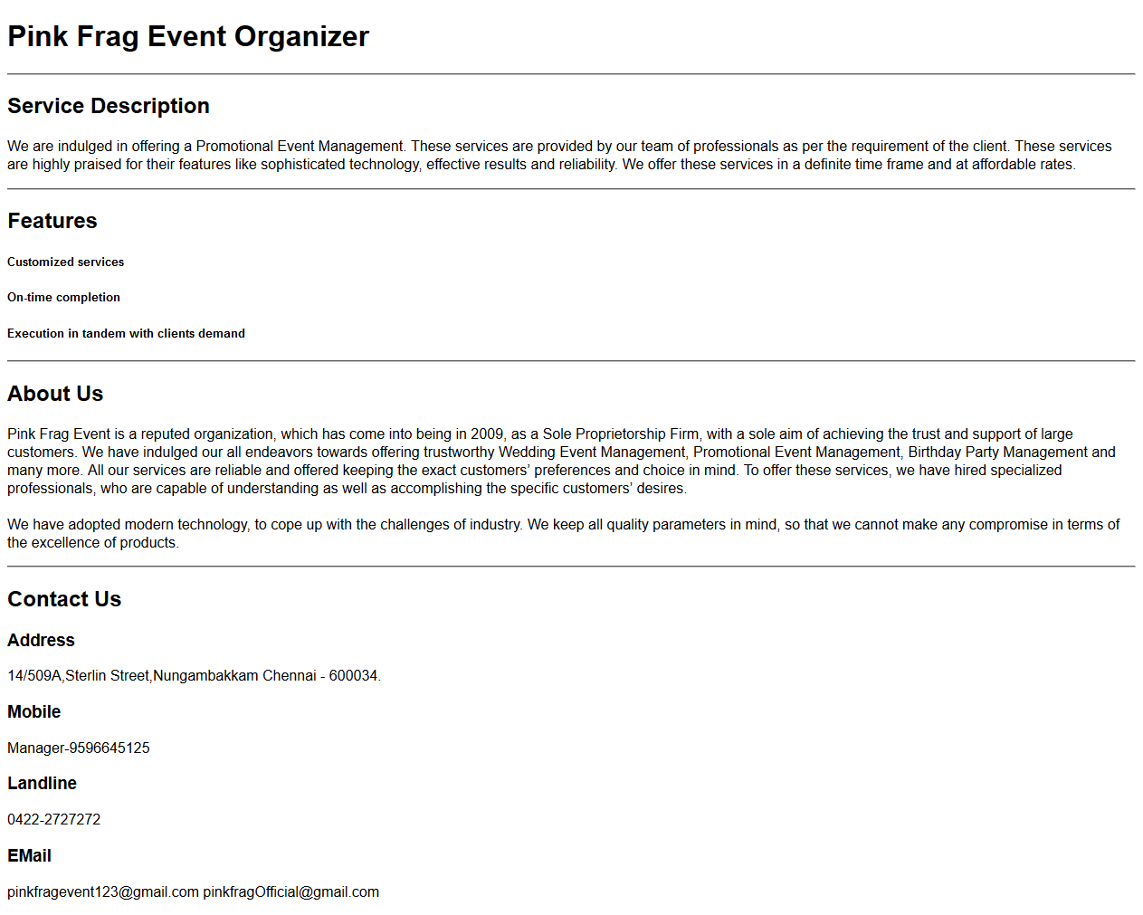  
  
**Sample Screenshot 2 :**  
  
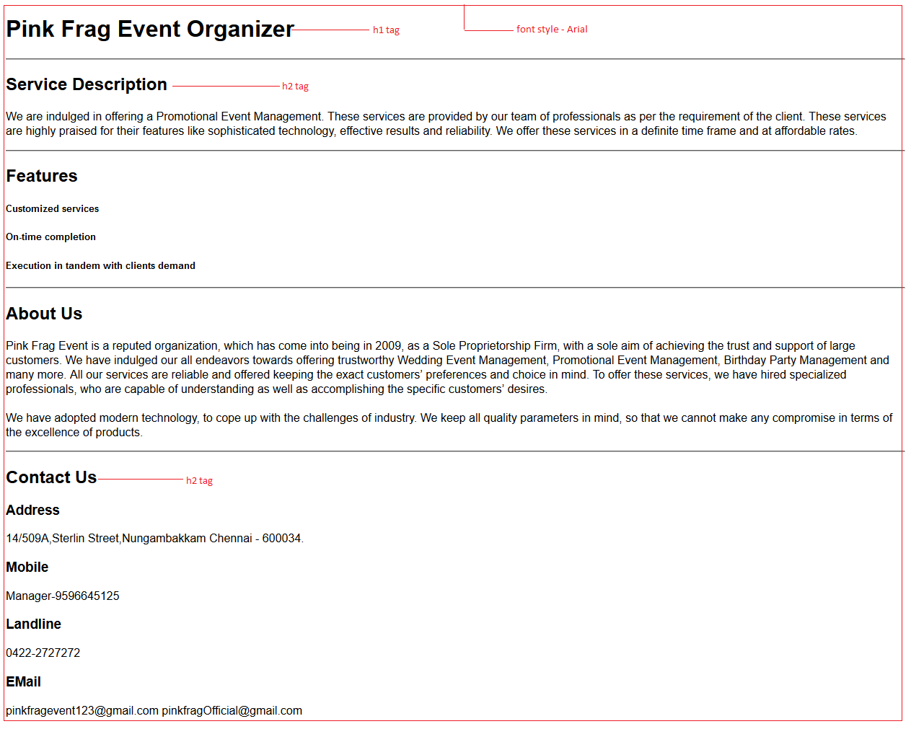

*2.HTML Basics - pre tag*

Alison Techno Solutions is planning to offer free online Java courses for school and college students. Part of the course will be based on how to write java programs and the explanation for the syntax and sourcecode used in it. The company hired a web designer to develop an online learning website and gave him the necessary course materials. The developer faced some difficulties in designing the web page of the course materials, when he came across to print programs. This is because to display the programs on the page, there are many variations involved in the alignment in the html code. Let us help him to print the pre-formatted text like the programs in the web page by using pre tag.

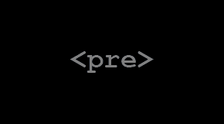

 Hints :

Tag <pre>

The HTML <pre> element represents preformatted text which is to be presented exactly as written in the HTML file.

Content :  
import java.util.*;  
class Main  
{  
    public static void main(String args[])  
    {  
        System.out.println("Hello World");  
    }  
}  
  
Constraints :  
Tag 'pre' must be present atleast 1 time.  
The java program must be same as given in the Content  
  
Note :  
Content of the page should be present as shown in the screenshot.  
Kindly refer the content which is given as a part of description.  
  
Sample Screenshot 1 :  
  
